PROJECT REPORT
(Project Term August-December 2018)

Word Scrammble
END TERM REPORT
By
NAME OF THE CANDIDATE(S)
Ashish Kumar (11717701)
Aniket Kushwaha(11700117)

Jitendra Verma(11717900)
Department of intelligent system
School of Computer Science Engineering
Lovely Professional University, Jalandhar
March-2018

DECLARATION
We hereby declare that the project work scramble game is an authentic record of our own work carried out as requirements of Minor Project for the award of B.Tech degree in B-Tech computer science engineering from Lovely Professional University, Phagwara, under the guidance of Vishu Maa’m, during August to November 2018. All the information furnished in this project report is based on our own intensive work and is genuine.
Project Group Number: 9
Name of Student 1 : Ashish Kumar
Registration Number: 11717701

Name of Student 2 :Aniket Kushwaha
Registration Number: 11700117

Name of Student 3 : Jitendra Verma
Registration Number:11717900

Signature of Ashish :

Signature of Aniket :

Signature of Jitendra :

Signature of Teacher:

ACKNOWLEDGEMENT
I take this precious opportunity to express my gratitude towards WORDS scrambble GAME to grant its permission for under going the training project. Without its willingness to permit this project would not have been succeed.
First of all, I would like to thanks all peoples who helped me directly or indirectly to complete my project whenever I found myself in problems. Our all faculties encourages me and due to their kindness and helpful nature and help I got very much confidence to complete the project.
I am deeply inherited who devoted his precious time in giving me the information about the various aspects and gave support and guidance at every point of time. I am really thankful to their support and a valuable time.
I also thanks to Vishu Maa’m for their motivation and support, I must thanks to my classmates for their timely help and support for compilation of this project.
Last but not the least, I would like to thanks all those who had helped directly or indirectly towards the completion of this project.

Table of Contents

1.Introduction………………………………………………………………………
2. Profile of problem……………………………………………………………...
3. Objective ………………………………………………………………………..
4. Tools and platform……………………………………………………………...
5. Scope of project………………………………………………………………...
6. Project Limitation…………………………………………………………........
7. Solving method …………………………………………………………………
8. Research methodology………………………………………………………….
9. Implementation Technique (Program code) …………………………………....
10. Output of implementation………………………………………………………
11. Conclusion……………………………………………………………………...
12. Suggestion for future improvement…………………………………………….
13. References……………………………………………………………………...

1. INTRODUCTION
Word scramble(also called word puzzle) are spoken or board games often designed to test ability with language or to explore its properties.
Word games are generally engaged as a source of entertainment, but have been found to serve an educational purpose as well. For instance, young children can find enjoyment playing modestly competitive games such as Hangman, while naturally developing important language skills like spelling. Solving crossword puzzles, which requires familiarity with a larger vocabulary, is a pastime that mature adults have long credited with keeping their minds sharp.
2. Profile of the Problem
The generator, on the other hand is currently rather poorly implemented. It works in that it successfully generates grids of a given words of a hints, but the variability of the time taken to generate is a significant weakness. Additionally, the generator currently only offers one levels of puzzle difficulty ,a scale of difficulties would be perhaps more useful.
3. Objective
Undergraduate research project work is very demanding of students, of tutors and of resources and many students and the transition from traditional from traditional practice work is difficult. In particular, they have unrealistic exception of what can be achieved. In order to prepare student for this project. This paper report on this case study on one much mini-project: making the aims and objectives unambiguous, achievable and explicit; recognising the nature and difficulty of the demands which are being made of students; and providing sufficient time, support and guidance of students.
4. Tools and platform
Minimum requirement:
Processor : intel core prcessor 3/intel core processor5
CPU speed : 1.4 GHz
RAM : 2 GB
Hard Disk : 8 GB
OS : Windows 7/10
Mouse
Keyboard
Sound Card : NO
Language : python 3.7
Server : Local system server

5. Scope of project
The objective of the proposed project is to increase the thinking capability.The game having all the records which you perform in playing you can select level according to your choice. You can make your own puzzle word and at any step you can go back .
It is manually a very difficult job to perform and its need a lot of recalling, reminding. The game of word puzzle help to increase mental thinking, vision etc.

6. Project Limitation
The problem faced by this system WORD SCRAMBLE GAME is this that it only run in desktop.
If you want to access this game then you must have python installed in your desktop. The limitation of this project that you not access it in your mobile device or in android devices.
7. Solving methods
A simple way to solve a word puzzle game is to simply moving a letter square boxes one by one and observe them weather they are forming a meaning word or not and try detect a smaller word in first priority as small meaningful word together can make big meaning word.
8. Research methodology
Requirement for users:
The basic requirement was to create a simple word puzzle game, where user can able to get different puzzles able to check and get solution for those puzzles, considering the requirements a simple 12x12 grid layout is made and discussed with the user to find out what exactly the expects the user interface to be. Some of the questions raised during discussion are.
- We have used python 3 for the coding part
- GUI part is designed using Tkinter
- We also used NLTK(natural language toolbar toolkit).it is use to enable python programs to work with human language data
- We have used ‘sqlite3’ for database storage
- Other modules used are ‘time’ and ‘random’
9. Implementation Technique (Source code)
Source code:-
from tkinter import* #tkinter module
from tkinter import messagebox
import time
import random
import sqlite3
import nltk
from nltk.corpus import words
#nltk.download('words')
word_list = words.words()
word=['baeutiful','diet','trojan','mouse','java','yuuca','libray','laid','technology','bad','demo','cabin',]
l_list=['A','B','C','D','E','F','H','K','T','N','S','J','L','I','M','O','R','U','W']
conn=sqlite3.connect('scarmble.db')
c=conn.cursor()
c.execute("drop table scramble")
c.execute("create table scramble(temp1 real)")
w=Tk()
w.geometry("1000x750")
f1=Frame(w,borderwidth=2)
f1.grid(row=0,column=0)
logo=PhotoImage(file="title.png")
l=Label(f1,image=logo)
l.grid(row=0,column=1)
f2=Frame(w,borderwidth=4)
f2.grid(row=1,column=0)
f3=Frame(w,borderwidth=2)
f3.grid(row=0,column=1)
label=Label(f3,text="Score = 0",bg="green", fg="Black",font=('Helvetica','20'))
label.grid(row=1,column=5)
hscore=Label(f3,text="highest Score = 0",bg="pink", fg="Black",font=('Helvetica','20'))
hscore.grid(row=1,column=6)
f4=Frame(w,borderwidth=2)
f4.grid(row=1,column=1)
label1=Label(f4,text="words found",bg="brown4", fg="Black",font=('Helvetica','15'))
label1.grid(row=2,column=1)
label2=Label(f4,text="letters selected= ",bg="cyan2", fg="Black",font=('Helvetica','20'))
label2.grid(row=0,column=1)
reset = Button(f4, text="Reset Letters",bg="dark orchid4", fg="white",font=('Helvetica','10'),command=lambda:reset1(reset))
reset.grid(column=1, row=1)
reset2 = Button(f2, text="Reset game",bg="black", fg="yellow",font=('Helvetica','10'),command=lambda:click1(reset2))
reset2.grid(row=13, column=14)
found=0
count=0
total=""
strg=""
score=0
strng=0
l=list()
w_found='words found'
l_found=""
def reset1(reset):
global strg
found=0
strg=""
l_found=strg
label2.configure(text="letters selected= "+l_found)
def click1(reset2):
global total
global found
global strg
global count
global l
global score
global w_found
global l_found
found=0
count=0
strg=""
score=0
strng=0
l=[]
total=""
w_found='words found'
l_found=""
label1.configure(text=w_found)
label.configure(text="score= 0")
label2.configure(text="letters selected= "+l_found)
btn11 = Button(f2, text=random.choice(l_list),bg="skyblue", fg="Black",width=3,height=1,font=('Helvetica','20'),command=lambda:click(btn11))
btn11.grid(column=1, row=1)
btn12 = Button(f2, text="",bg="thistle4", fg="Black",width=3,height=1,font=('Helvetica','20'),command=lambda:click(btn12))
btn12.grid(column=2, row=1)
btn13 = Button(f2, text=random.choice(l_list),bg="skyblue", fg="Black",width=3,height=1,font=('Helvetica','20'),command=lambda:click(btn13))
btn13.grid(column=3, row=1)
btn14 = Button(f2, text="",bg="thistle4", fg="Black",width=3,height=1,font=('Helvetica','20'),command=lambda:click(btn14))
btn14.grid(column=4, row=1)
btn15 = Button(f2, text="",bg="thistle4", fg="Black",width=3,height=1,font=('Helvetica','20'),command=lambda:click(btn15))
btn15.grid(column=5, row=1)
btn16 = Button(f2, text="",bg="thistle4", fg="Black",width=3,height=1,font=('Helvetica','20'),command=lambda:click(btn16))
btn16.grid(column=6, row=1)
btn17 = Button(f2, text="",bg="thistle4", fg="Black",width=3,height=1,font=('Helvetica','20'),command=lambda:click(btn17))
btn17.grid(column=7, row=1)
btn18 = Button(f2, text="L",bg="skyblue", fg="Black",width=3,height=1,font=('Helvetica','20'),command=lambda:click(btn18))
btn18.grid(column=8, row=1)
btn19 = Button(f2, text="",bg="thistle4", fg="Black",width=3,height=1,font=('Helvetica','20'),command=lambda:click(btn19))
btn19.grid(column=9, row=1)
btn110 = Button(f2, text="",bg="thistle4", fg="Black",width=3,height=1,font=('Helvetica','20'),command=lambda:click(btn110))
btn110.grid(column=10, row=1)
btn111a = Button(f2, text="",bg="thistle4", fg="Black",width=3,height=1,font=('Helvetica','20'),command=lambda:click(btn111a))
btn111a.grid(column=11, row=1)
btn11298 = Button(f2, text="",bg="thistle4", fg="Black",width=3,height=1,font=('Helvetica','20'),command=lambda:click(btn11298))
btn11298.grid(column=12, row=1)

btn21 = Button(f2, text="",bg="thistle4", fg="Black",width=3,height=1,font=('Helvetica','20'),command=lambda:click(btn21))
btn21.grid(column=1, row=2)
btn22 = Button(f2, text=random.choice(l_list),bg="skyblue", fg="Black",width=3,height=1,font=('Helvetica','20'),command=lambda:click(btn22))
btn22.grid(column=2, row=2)
btn23 = Button(f2, text="",bg="thistle4", fg="Black",width=3,height=1,font=('Helvetica','20'),command=lambda:click(btn23))
btn23.grid(column=3, row=2)
btn24 = Button(f2, text=random.choice(l_list),bg="skyblue", fg="Black",width=3,height=1,font=('Helvetica','20'),command=lambda:click(btn24))
btn24.grid(column=4, row=2)
btn25 = Button(f2, text="",bg="thistle4", fg="Black",width=3,height=1,font=('Helvetica','20'),command=lambda:click(btn25))
btn25.grid(column=5, row=2)
btn26 = Button(f2, text="",bg="thistle4", fg="Black",width=3,height=1,font=('Helvetica','20'),command=lambda:click(btn26))
btn26.grid(column=6, row=2)
btn27 = Button(f2, text="",bg="thistle4", fg="Black",width=3,height=1,font=('Helvetica','20'),command=lambda:click(btn27))
btn27.grid(column=7, row=2)
btn28 = Button(f2, text="",bg="thistle4", fg="Black",width=3,height=1,font=('Helvetica','20'),command=lambda:click(btn28))
btn28.grid(column=8, row=2)
btn29 = Button(f2, text="",bg="thistle4", fg="Black",width=3,height=1,font=('Helvetica','20'),command=lambda:click(btn29))
btn29.grid(column=9, row=2)
btn210 = Button(f2, text="",bg="thistle4", fg="Black",width=3,height=1,font=('Helvetica','20'),command=lambda:click(btn210))
btn210.grid(column=10, row=2)
btn211 = Button(f2, text=random.choice(l_list),bg="skyblue", fg="Black",width=3,height=1,font=('Helvetica','20'),command=lambda:click(btn211))
btn211.grid(column=11, row=2)
btn212 = Button(f2, text="",bg="thistle4", fg="Black",width=3,height=1,font=('Helvetica','20'),command=lambda:click(btn212))
btn212.grid(column=12, row=2)

btn31 = Button(f2, text="M",bg="skyblue", fg="Black",width=3,height=1,font=('Helvetica','20'),command=lambda:click(btn31))
btn31.grid(column=1, row=3)
btn32 = Button(f2, text=random.choice(l_list),bg="skyblue", fg="Black",width=3,height=1,font=('Helvetica','20'),command=lambda:click(btn32))
btn32.grid(column=2, row=3)
btn33 = Button(f2, text="",bg="thistle4", fg="Black",width=3,height=1,font=('Helvetica','20'),command=lambda:click(btn33))
btn33.grid(column=3, row=3)
btn34 = Button(f2, text="",bg="thistle4", fg="Black",width=3,height=1,font=('Helvetica','20'),command=lambda:click(btn34))
btn34.grid(column=4, row=3)
btn35 = Button(f2, text=random.choice(l_list),bg="skyblue", fg="Black",width=3,height=1,font=('Helvetica','20'),command=lambda:click(btn35))
btn35.grid(column=5, row=3)
btn36 = Button(f2, text="",bg="thistle4", fg="Black",width=3,height=1,font=('Helvetica','20'),command=lambda:click(btn36))
btn36.grid(column=6, row=3)
btn37 = Button(f2, text="",bg="thistle4", fg="Black",width=3,height=1,font=('Helvetica','20'),command=lambda:click(btn37))
btn37.grid(column=7, row=3)
btn38 = Button(f2, text="",bg="thistle4", fg="Black",width=3,height=1,font=('Helvetica','20'),command=lambda:click(btn38))
btn38.grid(column=8, row=3)
btn39 = Button(f2, text="",bg="thistle4", fg="Black",width=3,height=1,font=('Helvetica','20'),command=lambda:click(btn39))
btn39.grid(column=9, row=3)
btn310 = Button(f2, text="",bg="thistle4", fg="Black",width=3,height=1,font=('Helvetica','20'),command=lambda:click(btn310))
btn310.grid(column=10, row=3)
btn311 = Button(f2, text="",bg="thistle4", fg="Black",width=3,height=1,font=('Helvetica','20'),command=lambda:click(btn311))
btn311.grid(column=11, row=3)
btn312 = Button(f2, text="",bg="thistle4", fg="Black",width=3,height=1,font=('Helvetica','20'),command=lambda:click(btn312))
btn312.grid(column=12, row=3)

btn41 = Button(f2, text=random.choice(l_list),bg="skyblue", fg="Black",width=3,height=1,font=('Helvetica','20'),command=lambda:click(btn41))
btn41.grid(column=1, row=4)
btn42 = Button(f2, text=random.choice(l_list),bg="skyblue", fg="Black",width=3,height=1,font=('Helvetica','20'),command=lambda:click(btn42))
btn42.grid(column=2, row=4)
btn43 = Button(f2, text="",bg="thistle4", fg="Black",width=3,height=1,font=('Helvetica','20'),command=lambda:click(btn43))
btn43.grid(column=3, row=4)
btn44 = Button(f2, text="",bg="thistle4", fg="Black",width=3,height=1,font=('Helvetica','20'),command=lambda:click(btn44))
btn44.grid(column=4, row=4)
btn45 = Button(f2, text="",bg="thistle4", fg="Black",width=3,height=1,font=('Helvetica','20'),command=lambda:click(btn45))
btn45.grid(column=5, row=4)
btn46 = Button(f2, text="",bg="thistle4", fg="Black",width=3,height=1,font=('Helvetica','20'),command=lambda:click(btn46))
btn46.grid(column=6, row=4)
btn47 = Button(f2, text="",bg="thistle4", fg="Black",width=3,height=1,font=('Helvetica','20'),command=lambda:click(btn47))
btn47.grid(column=7, row=4)
btn48 = Button(f2, text="",bg="thistle4", fg="Black",width=3,height=1,font=('Helvetica','20'),command=lambda:click(btn48))
btn48.grid(column=8, row=4)
btn49 = Button(f2, text=random.choice(l_list),bg="skyblue", fg="Black",width=3,height=1,font=('Helvetica','20'),command=lambda:click(btn49))
btn49.grid(column=9, row=4)
btn410 = Button(f2, text="",bg="thistle4", fg="Black",width=3,height=1,font=('Helvetica','20'),command=lambda:click(btn410))
btn410.grid(column=10, row=4)
btn411 = Button(f2, text="",bg="thistle4", fg="Black",width=3,height=1,font=('Helvetica','20'),command=lambda:click(btn411))
btn411.grid(column=11, row=4)
btn412 = Button(f2, text="",bg="thistle4", fg="Black",width=3,height=1,font=('Helvetica','20'),command=lambda:click(btn412))
btn412.grid(column=12, row=4)

btn51 = Button(f2, text="",bg="thistle4", fg="Black",width=3,height=1,font=('Helvetica','20'),command=lambda:click(btn51))
btn51.grid(column=1, row=5)
btn52 = Button(f2, text="",bg="thistle4", fg="Black",width=3,height=1,font=('Helvetica','20'),command=lambda:click(btn52))
btn52.grid(column=2, row=5)
btn53 = Button(f2, text="",bg="thistle4", fg="Black",width=3,height=1,font=('Helvetica','20'),command=lambda:click(btn53))
btn53.grid(column=3, row=5)
btn54 = Button(f2, text=random.choice(l_list),bg="skyblue", fg="Black",width=3,height=1,font=('Helvetica','20'),command=lambda:click(btn54))
btn54.grid(column=4, row=5)
btn55 = Button(f2, text=random.choice(l_list),bg="skyblue", fg="Black",width=3,height=1,font=('Helvetica','20'),command=lambda:click(btn55))
btn55.grid(column=5, row=5)
btn56 = Button(f2, text="",bg="thistle4", fg="Black",width=3,height=1,font=('Helvetica','20'),command=lambda:click(btn56))
btn56.grid(column=6, row=5)
btn57 = Button(f2, text="",bg="thistle4", fg="Black",width=3,height=1,font=('Helvetica','20'),command=lambda:click(btn57))
btn57.grid(column=7, row=5)
btn58 = Button(f2, text="",bg="thistle4", fg="Black",width=3,height=1,font=('Helvetica','20'),command=lambda:click(btn58))
btn58.grid(column=8, row=5)
btn59 = Button(f2, text=random.choice(l_list),bg="skyblue", fg="Black",width=3,height=1,font=('Helvetica','20'),command=lambda:click(btn59))
btn59.grid(column=9, row=5)
btn510 = Button(f2, text=random.choice(l_list),bg="skyblue", fg="Black",width=3,height=1,font=('Helvetica','20'),command=lambda:click(btn510))
btn510.grid(column=10, row=5)
btn511 = Button(f2, text="",bg="thistle4", fg="Black",width=3,height=1,font=('Helvetica','20'),command=lambda:click(btn511))
btn511.grid(column=11, row=5)
btn512 = Button(f2, text="",bg="thistle4", fg="Black",width=3,height=1,font=('Helvetica','20'),command=lambda:click(btn512))
btn512.grid(column=12, row=5)

btn61 = Button(f2, text=random.choice(l_list),bg="skyblue", fg="Black",width=3,height=1,font=('Helvetica','20'),command=lambda:click(btn61))
btn61.grid(column=1, row=6)
btn62 = Button(f2, text="",bg="thistle4", fg="Black",width=3,height=1,font=('Helvetica','20'),command=lambda:click(btn62))
btn62.grid(column=2, row=6)
btn63 = Button(f2, text="",bg="thistle4", fg="Black",width=3,height=1,font=('Helvetica','20'),command=lambda:click(btn63))
btn63.grid(column=3, row=6)
btn64 = Button(f2, text="",bg="thistle4", fg="Black",width=3,height=1,font=('Helvetica','20'),command=lambda:click(btn64))
btn64.grid(column=4, row=6)
btn65 = Button(f2, text=random.choice(l_list),bg="skyblue", fg="Black",width=3,height=1,font=('Helvetica','20'),command=lambda:click(btn65))
btn65.grid(column=5, row=6)
btn66 = Button(f2, text="",bg="thistle4", fg="Black",width=3,height=1,font=('Helvetica','20'),command=lambda:click(btn66))
btn66.grid(column=6, row=6)
btn67 = Button(f2, text="",bg="thistle4", fg="Black",width=3,height=1,font=('Helvetica','20'),command=lambda:click(btn67))
btn67.grid(column=7, row=6)
btn68 = Button(f2, text="j",bg="skyblue", fg="Black",width=3,height=1,font=('Helvetica','20'),command=lambda:click(btn68))
btn68.grid(column=8, row=6)
btn69 = Button(f2, text="",bg="thistle4", fg="Black",width=3,height=1,font=('Helvetica','20'),command=lambda:click(btn69))
btn69.grid(column=9, row=6)
btn610 = Button(f2, text="",bg="thistle4", fg="Black",width=3,height=1,font=('Helvetica','20'),command=lambda:click(btn610))
btn610.grid(column=10, row=6)
btn611 = Button(f2, text="U",bg="skyblue", fg="Black",width=3,height=1,font=('Helvetica','20'),command=lambda:click(btn611))
btn611.grid(column=11, row=6)
btn612 = Button(f2, text="",bg="thistle4", fg="Black",width=3,height=1,font=('Helvetica','20'),command=lambda:click(btn612))
btn612.grid(column=12, row=6)

btn71 = Button(f2, text="",bg="thistle4", fg="Black",width=3,height=1,font=('Helvetica','20'),command=lambda:click(btn71))
btn71.grid(column=1, row=7)
btn72 = Button(f2, text="F",bg="skyblue", fg="Black",width=3,height=1,font=('Helvetica','20'),command=lambda:click(btn72))
btn72.grid(column=2, row=7)
btn73 = Button(f2, text="",bg="thistle4", fg="Black",width=3,height=1,font=('Helvetica','20'),command=lambda:click(btn73))
btn73.grid(column=3, row=7)
btn74 = Button(f2, text="",bg="thistle4", fg="Black",width=3,height=1,font=('Helvetica','20'),command=lambda:click(btn74))
btn74.grid(column=4, row=7)
btn75 = Button(f2, text="",bg="thistle4", fg="Black",width=3,height=1,font=('Helvetica','20'),command=lambda:click(btn75))
btn75.grid(column=5, row=7)
btn76 = Button(f2, text=random.choice(l_list),bg="skyblue", fg="Black",width=3,height=1,font=('Helvetica','20'),command=lambda:click(btn76))
btn76.grid(column=6, row=7)
btn77 = Button(f2, text="",bg="thistle4", fg="Black",width=3,height=1,font=('Helvetica','20'),command=lambda:click(btn77))
btn77.grid(column=7, row=7)
btn78 = Button(f2, text="",bg="thistle4", fg="Black",width=3,height=1,font=('Helvetica','20'),command=lambda:click(btn78))
btn78.grid(column=8, row=7)
btn79 = Button(f2, text=random.choice(l_list),bg="skyblue", fg="Black",width=3,height=1,font=('Helvetica','20'),command=lambda:click(btn79))
btn79.grid(column=9, row=7)
btn710 = Button(f2, text="",bg="thistle4", fg="Black",width=3,height=1,font=('Helvetica','20'),command=lambda:click(btn710))
btn710.grid(column=10, row=7)
btn711 = Button(f2, text=random.choice(l_list),bg="skyblue", fg="Black",width=3,height=1,font=('Helvetica','20'),command=lambda:click(btn711))
btn711.grid(column=11, row=7)
btn712 = Button(f2, text="",bg="thistle4", fg="Black",width=3,height=1,font=('Helvetica','20'),command=lambda:click(btn712))
btn712.grid(column=12, row=7)

btn81 = Button(f2,text="",bg="thistle4", fg="Black",width=3,height=1,font=('Helvetica','20'),command=lambda:click(btn81))
btn81.grid(column=1, row=8)
btn82 = Button(f2, text=random.choice(l_list),bg="skyblue", fg="Black",width=3,height=1,font=('Helvetica','20'),command=lambda:click(btn82))
btn82.grid(column=2, row=8)
btn83 = Button(f2, text="",bg="thistle4", fg="Black",width=3,height=1,font=('Helvetica','20'),command=lambda:click(btn83))
btn83.grid(column=3, row=8)
btn84 = Button(f2, text="",bg="thistle4", fg="Black",width=3,height=1,font=('Helvetica','20'),command=lambda:click(btn84))
btn84.grid(column=4, row=8)
btn85 = Button(f2, text="",bg="thistle4", fg="Black",width=3,height=1,font=('Helvetica','20'),command=lambda:click(btn85))
btn85.grid(column=5, row=8)
btn86 = Button(f2, text="",bg="thistle4", fg="Black",width=3,height=1,font=('Helvetica','20'),command=lambda:click(btn86))
btn86.grid(column=6, row=8)
btn87 = Button(f2, text="",bg="thistle4", fg="Black",width=3,height=1,font=('Helvetica','20'),command=lambda:click(btn87))
btn87.grid(column=7, row=8)
btn88 = Button(f2, text=random.choice(l_list),bg="skyblue", fg="Black",width=3,height=1,font=('Helvetica','20'),command=lambda:click(btn88))
btn88.grid(column=8, row=8)
btn89 = Button(f2, text="",bg="thistle4", fg="Black",width=3,height=1,font=('Helvetica','20'),command=lambda:click(btn89))
btn89.grid(column=9, row=8)
btn810 = Button(f2, text="",bg="thistle4", fg="Black",width=3,height=1,font=('Helvetica','20'),command=lambda:click(btn810))
btn810.grid(column=10, row=8)
btn811 = Button(f2, text="",bg="thistle4", fg="Black",width=3,height=1,font=('Helvetica','20'),command=lambda:click(btn811))
btn811.grid(column=11, row=8)
btn812 = Button(f2, text=random.choice(l_list),bg="skyblue", fg="Black",width=3,height=1,font=('Helvetica','20'),command=lambda:click(btn812))
btn812.grid(column=12, row=8)

btn91 = Button(f2, text=random.choice(l_list),bg="skyblue", fg="Black",width=3,height=1,font=('Helvetica','20'),command=lambda:click(btn91))
btn91.grid(column=1, row=9)
btn92 = Button(f2, text="",bg="thistle4", fg="Black",width=3,height=1,font=('Helvetica','20'),command=lambda:click(btn92))
btn92.grid(column=2, row=9)
btn93 = Button(f2, text="I",bg="skyblue", fg="Black",width=3,height=1,font=('Helvetica','20'),command=lambda:click(btn93))
btn93.grid(column=3, row=9)
btn94 = Button(f2, text=random.choice(l_list),bg="skyblue", fg="Black",width=3,height=1,font=('Helvetica','20'),command=lambda:click(btn94))
btn94.grid(column=4, row=9)
btn95 = Button(f2, text="",bg="thistle4", fg="Black",width=3,height=1,font=('Helvetica','20'),command=lambda:click(btn95))
btn95.grid(column=5, row=9)
btn96 = Button(f2, text="",bg="thistle4", fg="Black",width=3,height=1,font=('Helvetica','20'),command=lambda:click(btn96))
btn96.grid(column=6, row=9)
btn97 = Button(f2, text="",bg="thistle4", fg="Black",width=3,height=1,font=('Helvetica','20'),command=lambda:click(btn97))
btn97.grid(column=7, row=9)
btn98 = Button(f2, text="y",bg="skyblue", fg="Black",width=3,height=1,font=('Helvetica','20'),command=lambda:click(btn98))
btn98.grid(column=8, row=9)
btn99 = Button(f2, text="",bg="thistle4", fg="Black",width=3,height=1,font=('Helvetica','20'),command=lambda:click(btn99))
btn99.grid(column=9, row=9)
btn910 = Button(f2, text="",bg="thistle4", fg="Black",width=3,height=1,font=('Helvetica','20'),command=lambda:click(btn910))
btn910.grid(column=10, row=9)
btn911 = Button(f2, text="",bg="thistle4", fg="Black",width=3,height=1,font=('Helvetica','20'),command=lambda:click(btn911))
btn911.grid(column=11, row=9)
btn912 = Button(f2, text=random.choice(l_list),bg="skyblue", fg="Black",width=3,height=1,font=('Helvetica','20'),command=lambda:click(btn912))
btn912.grid(column=12, row=9)

btn101 = Button(f2, text="",bg="thistle4", fg="Black",width=3,height=1,font=('Helvetica','20'),command=lambda:click(btn101))
btn101.grid(column=1, row=10)
btn102 = Button(f2, text="",bg="thistle4", fg="Black",width=3,height=1,font=('Helvetica','20'),command=lambda:click(btn102))
btn102.grid(column=2, row=10)
btn103 = Button(f2, text="",bg="thistle4", fg="Black",width=3,height=1,font=('Helvetica','20'),command=lambda:click(btn103))
btn103.grid(column=3, row=10)
btn104 = Button(f2, text="",bg="thistle4", fg="Black",width=3,height=1,font=('Helvetica','20'),command=lambda:click(btn104))
btn104.grid(column=4, row=10)
btn105 = Button(f2, text="",bg="thistle4", fg="Black",width=3,height=1,font=('Helvetica','20'),command=lambda:click(btn105))
btn105.grid(column=5, row=10)
btn106 = Button(f2, text=random.choice(l_list),bg="skyblue", fg="Black",width=3,height=1,font=('Helvetica','20'),command=lambda:click(btn106))
btn106.grid(column=6, row=10)
btn107 = Button(f2, text="",bg="thistle4", fg="Black",width=3,height=1,font=('Helvetica','20'),command=lambda:click(btn107))
btn107.grid(column=7, row=10)
btn108 = Button(f2, text="",bg="thistle4", fg="Black",width=3,height=1,font=('Helvetica','20'),command=lambda:click(btn108))
btn108.grid(column=8, row=10)
btn109 = Button(f2, text="",bg="thistle4", fg="Black",width=3,height=1,font=('Helvetica','20'),command=lambda:click(btn109))
btn109.grid(column=9, row=10)
btn1010 = Button(f2, text="",bg="thistle4", fg="Black",width=3,height=1,font=('Helvetica','20'),command=lambda:click(btn1010))
btn1010.grid(column=10, row=10)
btn1011 = Button(f2, text="",bg="thistle4", fg="Black",width=3,height=1,font=('Helvetica','20'),command=lambda:click(btn1011))
btn1011.grid(column=11, row=10)
btn1012 = Button(f2, text=random.choice(l_list),bg="skyblue", fg="Black",width=3,height=1,font=('Helvetica','20'),command=lambda:click(btn1012))
btn1012.grid(column=12, row=10)

btn111 = Button(f2, text="",bg="thistle4", fg="Black",width=3,height=1,font=('Helvetica','20'),command=lambda:click(btn111))
btn111.grid(column=1, row=11)
btn112 = Button(f2, text="",bg="thistle4", fg="Black",width=3,height=1,font=('Helvetica','20'),command=lambda:click(btn112))
btn112.grid(column=2, row=11)
btn113 = Button(f2, text=random.choice(l_list),bg="skyblue", fg="Black",width=3,height=1,font=('Helvetica','20'),command=lambda:click(btn113))
btn113.grid(column=3, row=11)
btn114 = Button(f2, text="",bg="thistle4", fg="Black",width=3,height=1,font=('Helvetica','20'),command=lambda:click(btn114))
btn114.grid(column=4, row=11)
btn115 = Button(f2, text="",bg="thistle4", fg="Black",width=3,height=1,font=('Helvetica','20'),command=lambda:click(btn115))
btn115.grid(column=5, row=11)
btn116 = Button(f2, text="",bg="thistle4", fg="Black",width=3,height=1,font=('Helvetica','20'),command=lambda:click(btn116))
btn116.grid(column=6, row=11)
btn117 = Button(f2, text=random.choice(l_list),bg="skyblue", fg="Black",width=3,height=1,font=('Helvetica','20'),command=lambda:click(btn117))
btn117.grid(column=7, row=11)
btn118 = Button(f2, text="",bg="thistle4", fg="Black",width=3,height=1,font=('Helvetica','20'),command=lambda:click(btn118))
btn118.grid(column=8, row=11)
btn119 = Button(f2, text="",bg="thistle4", fg="Black",width=3,height=1,font=('Helvetica','20'),command=lambda:click(btn119))
btn119.grid(column=9, row=11)
btn1110 = Button(f2, text="",bg="thistle4", fg="Black",width=3,height=1,font=('Helvetica','20'),command=lambda:click(btn1110))
btn1110.grid(column=10, row=11)
btn1111 = Button(f2, text="",bg="thistle4", fg="Black",width=3,height=1,font=('Helvetica','20'),command=lambda:click(btn1111))
btn1111.grid(column=11, row=11)
btn1112 = Button(f2, text=random.choice(l_list),bg="skyblue", fg="Black",width=3,height=1,font=('Helvetica','20'),command=lambda:click(btn1112))
btn1112.grid(column=12, row=11)

btn121 = Button(f2, text="",bg="thistle4", fg="Black",width=3,height=1,font=('Helvetica','20'),command=lambda:click(btn121))
btn121.grid(column=1, row=12)
btn122 = Button(f2, text="",bg="thistle4", fg="Black",width=3,height=1,font=('Helvetica','20'),command=lambda:click(btn122))
btn122.grid(column=2, row=12)
btn123 = Button(f2, text=random.choice(l_list),bg="skyblue", fg="Black",width=3,height=1,font=('Helvetica','20'),command=lambda:click(btn123))
btn123.grid(column=3, row=12)
btn124 = Button(f2, text="",bg="thistle4", fg="Black",width=3,height=1,font=('Helvetica','20'),command=lambda:click(btn124))
btn124.grid(column=4, row=12)
btn125 = Button(f2, text="",bg="thistle4", fg="Black",width=3,height=1,font=('Helvetica','20'),command=lambda:click(btn125))
btn125.grid(column=5, row=12)
btn126 = Button(f2, text="",bg="thistle4", fg="Black",width=3,height=1,font=('Helvetica','20'),command=lambda:click(btn126))
btn126.grid(column=6, row=12)
btn127 = Button(f2, text="N",bg="skyblue", fg="Black",width=3,height=1,font=('Helvetica','20'),command=lambda:click(btn127))
btn127.grid(column=7, row=12)
btn128 = Button(f2, text="",bg="thistle4", fg="Black",width=3,height=1,font=('Helvetica','20'),command=lambda:click(btn128))
btn128.grid(column=8, row=12)
btn129 = Button(f2, text="",bg="thistle4", fg="Black",width=3,height=1,font=('Helvetica','20'),command=lambda:click(btn129))
btn129.grid(column=9, row=12)
btn1210 = Button(f2, text="",bg="thistle4", fg="Black",width=3,height=1,font=('Helvetica','20'),command=lambda:click(bnt1210))
btn1210.grid(column=10, row=12)
btn1211 = Button(f2, text="",bg="thistle4", fg="Black",width=3,height=1,font=('Helvetica','20'),command=lambda:click(btn1211))
btn1211.grid(column=11, row=12)
btn1212 = Button(f2, text="",bg="thistle4", fg="Black",width=3,height=1,font=('Helvetica','20'),command=lambda:click(btn1212))
btn1212.grid(column=12, row=12
def click(b):
print("function called")
global found
global total
global strg
global count
global l
global score
global w_found
global l_found
global c
global conn
if(b["text"]==""):
found=1
messagebox.showinfo("OOPS!!!!!!!!","wrong!!!! button")

else:

if(found==0):
strg=strg+b["text"]
strg=strg.lower()
l_found=strg
label2.configure(text="letters selected= "+l_found)
print(strg)
if(len(strg)>2):
print('true')
if(strg in word_list):
print('accesed')
found=1
if(strg in l):
found=0
return
w_found=w_found+"\n"+strg
score=score+len(strg)
c.execute("insert into scramble(temp1) values(92)",)
total="score = "+str(score)
label.configure(text=total)
l.append(strg)
print(l)
label1.configure(text=w_found)
elif(strg in word):
print('accesed')
found=1
if(strg in l):
found=0
return
w_found=w_found+"\n"+strg
score=score+len(strg)
c.execute("insert into scramble values(temp1) values(92),")
total="score = "+str(score)
label.configure(text=total)
l.append(strg)
print(l)
label1.configure(text=w_found)
if(found==1):
found=0
strg=""
l_found=strg
label2.configure(text="letters selected= "+l_found)
c.execute('select max(temp1) from scramble')
k=c.fetchone()
k=str(k)
hscore.configure(text="highest Score = "+k)
conn.commit()
c.execute('select max(temp1) from scramble')
k=c.fetchone()
k=str(k)
hscore.configure(text="highest Score = "+k)
conn.commit()
def tick(time1=''): ##timer
time2=time.strftime("%M:%S",)
if(time2!=time1):
time1=time2;
timer.config(fg="red",bg="black",font=('Helvetica','10'),text="After 1 minute it will close automatically"+time2)
timer.after(200,tick)
def quit_pro():
messagebox.showinfo("OOPS!!!!!!!!","Times UP!!!! Your Score"+str(score))
w.destroy()
timer=Label(w,text="you have 1 minute")
timer.grid(column=0,row=6)
tick()
w.after(60000,quit_pro)
w.mainloop()

Language of implantation:
For this project chose to use python as a programming language. This was simply due to it being the language I has been using most recently. A constraint programming language like prolong would be have better suited to this task since such language includes the ability of solving some work automatically, However, I have no experience in using programming paradigm.
Source code :
The snapshot of source code of program:

10. Output of implementation
The snapshot of output of project:
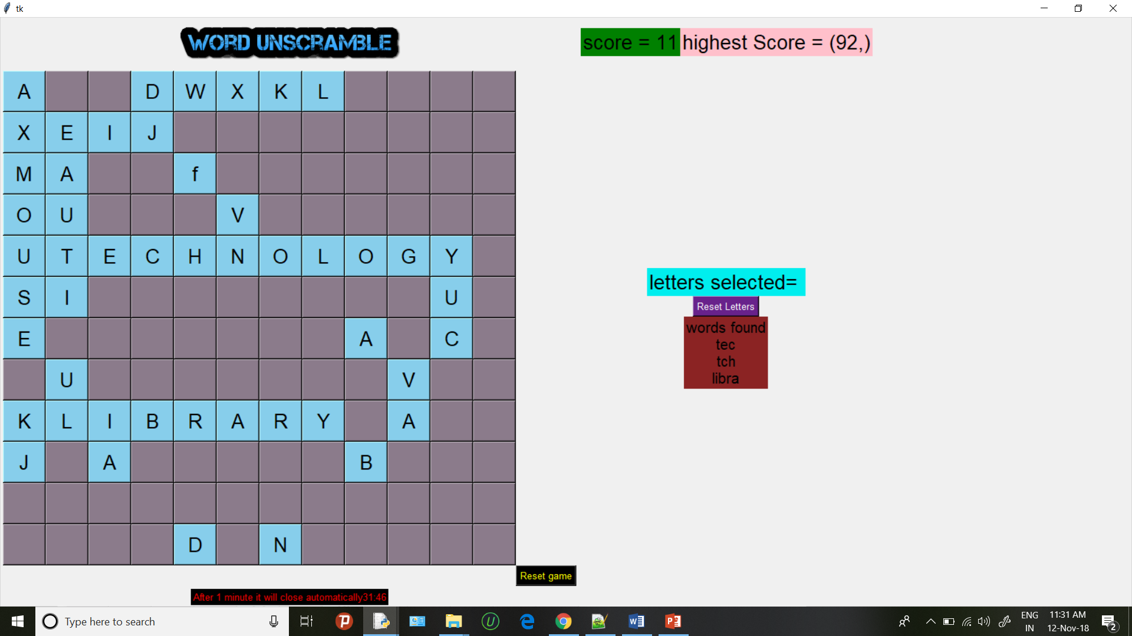
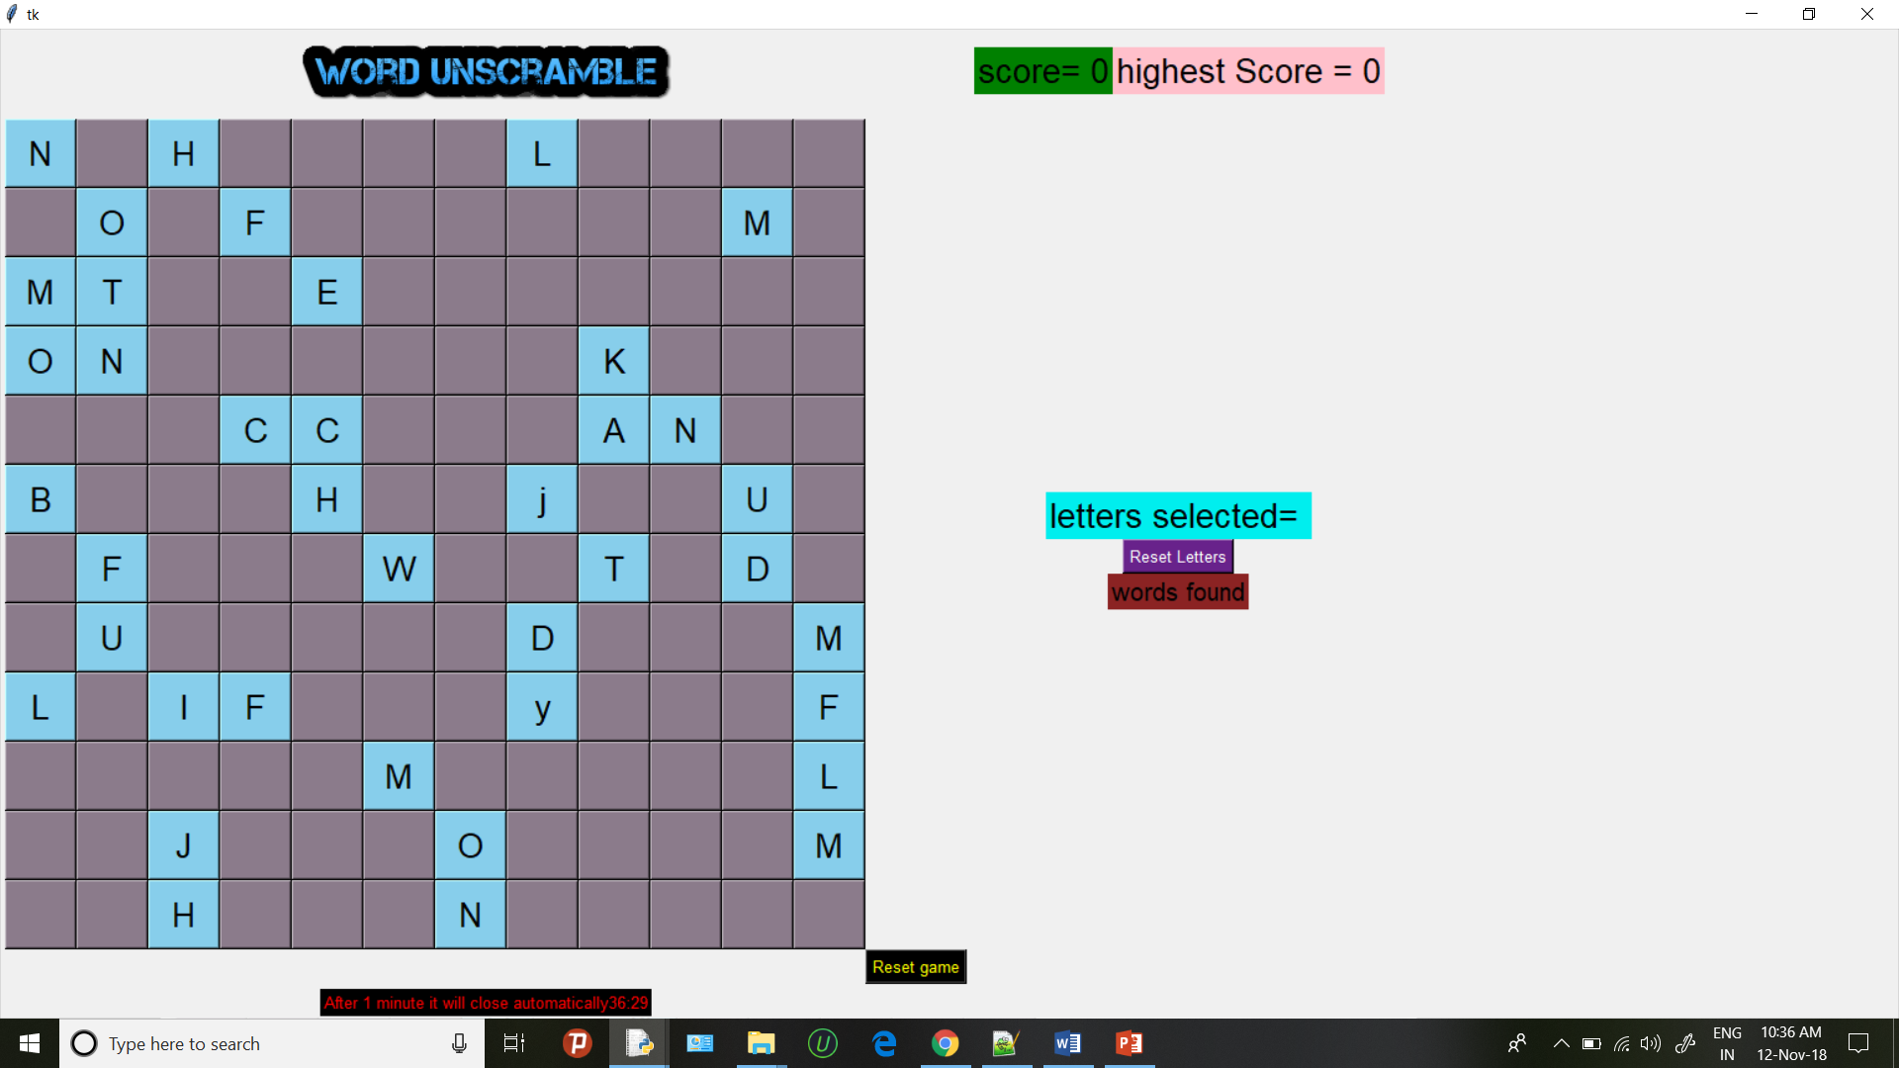
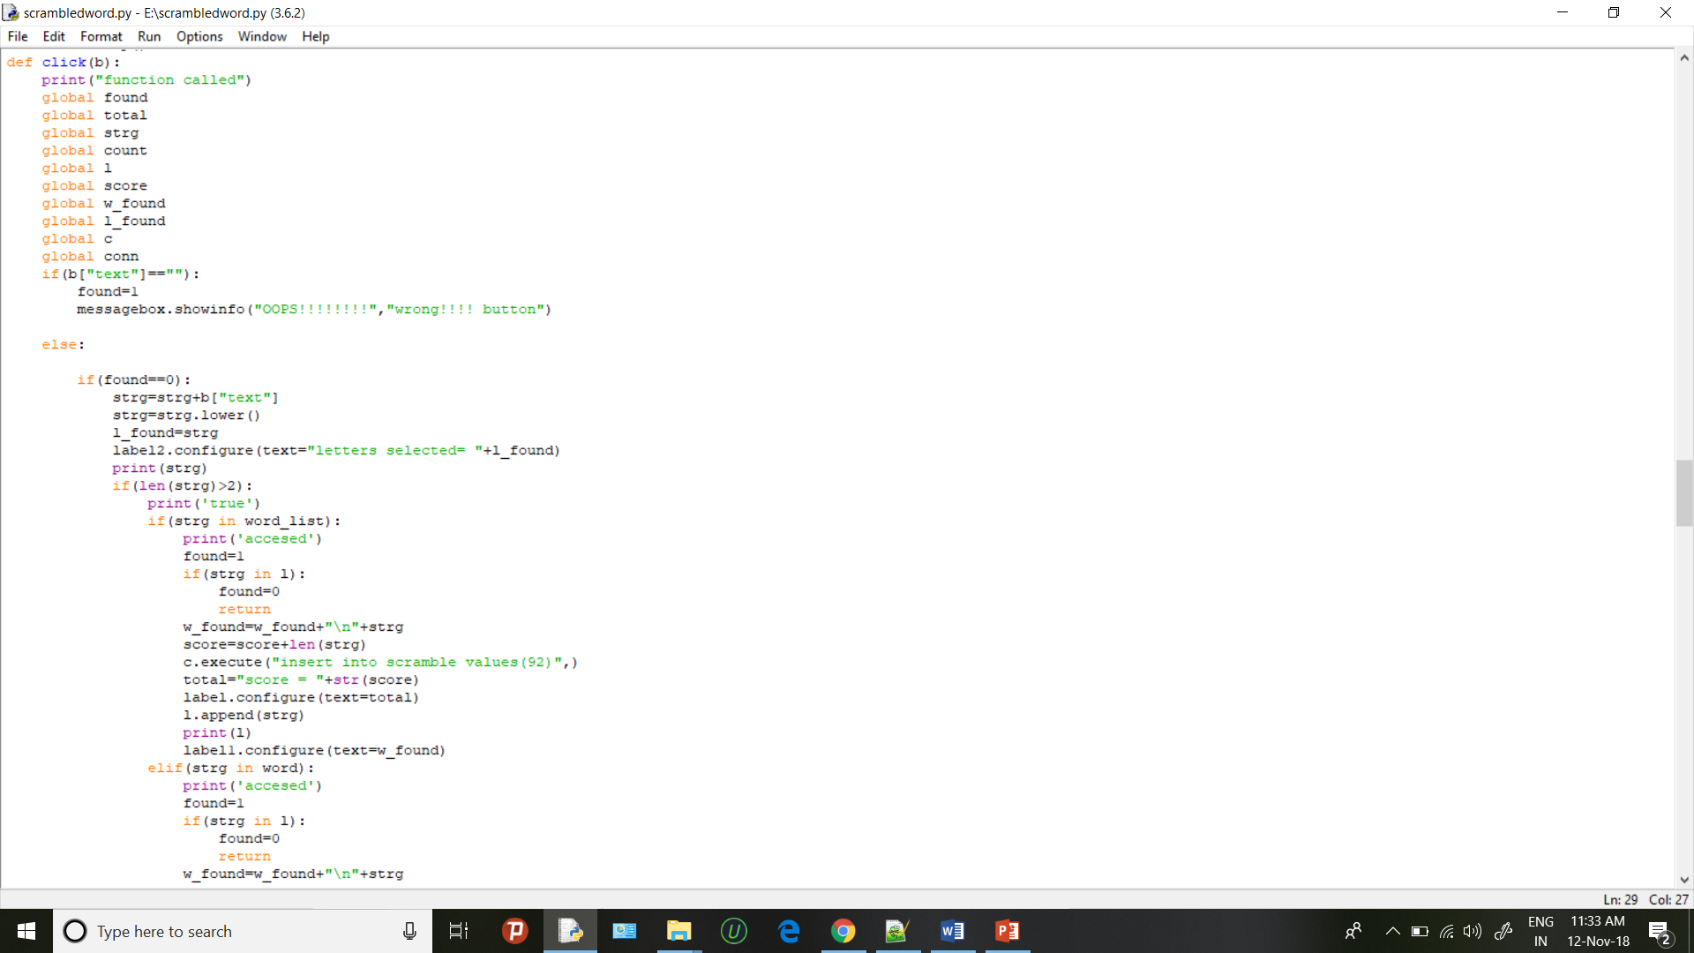

11. Conclusion
Achievements:
Through generating this word puzzle game I feel I have improves my programming ability. This was perhaps the largest program in the terms of time invested and lines of code written that I have created. The code is not of high quality, and it is several lacking in documentation, but some of the problem posed by the project were a good challenge to solve. Writing the solver has demonstrated the advantages of algorithm finally, I have experienced participating in what I could be called small research project(useful for future work)
Project status:
The logic solver portion of the program is sufficient for solving many word puzzle. However, the implementation could likely be improved to execute faster. Furthermore, there are many logics solving techniques that have not been implemented.
The generator on the other hand is currently rather poorly implemented. It works in that it successfully generates grids of a given numbers of hints, but the variability of a time to generate is a significant weakness.

12. Suggestion for future improvement
These are some of the main suggestions given by the user for improvement.
I. Instant help by giving hints and user progress while playing.
II. Score system based on time and accuracy, and database to keep track of top record.
13. References
I:- www.nltk.com
II:- www.tutorialpoint.com
III:- www.scribid.com
IV:- www.codelearner.com

